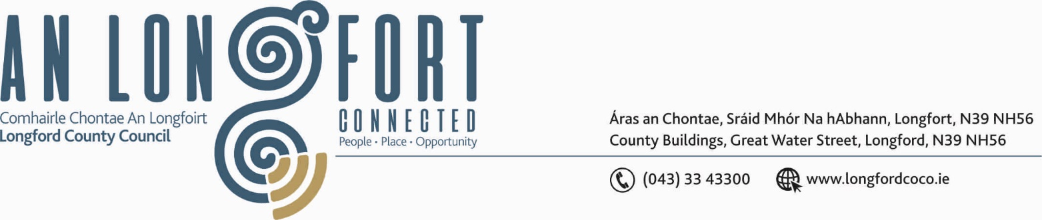

LONGFORD MUNICIPAL DISTRICT

17th January 2019.

To: Each Member of Longford Municipal District.

Dear Member,

You are requested to attend Meeting of Longford Municipal District to be held in the Council Chamber, Town Hall, Market Square, Longford, on Wednesday, 23rd January 2019 at
4.00 p.m. to transact business, as set out on the Agenda hereunder.

6.00 p.m.
Reception for Tidy Towns volunteers.

Yours sincerely,


_______________
Anne Lee,
Meetings Administrator.

AGENDA

Prayer before meeting.

- Confirmation of Minutes of Longford Municipal District Meetings held on the
28th November 2018 – copy enclosed.

2. Matters arising from Minutes.

- Management Report - enclosed.

- Consideration of Nominee for the 2019 Cathaoirleach Awards.

- Consideration of Adoption of Part 8 Report (Planning and Development Act 2000 (as amended) and Planning and Development Regulations 2001) (as amended) in respect of the construction of an Industrial Unit at Lisnamuck, IDA Business Park, Ballinalee Road, Longford - details attached.

- Notices of Motions, submitted by Councillors, as listed hereunder –

Councillor Peggy Nolan.

“I am calling on this Municipal District to make a once-off payment to Attic House from our resources, to support their project and ensure its success.”

- Correspondence – enclosed

(i) Letter dated 7th January 2019 received from Irish Water Support Desk regarding sewerage network in the Ferefad, Knockahaw and Dublin Road areas of Longford town.



